CREATE WORKFLOW STEP BY STEP

STEP 1 - Create API Management
The first step is to create an API for the engine (stored procedure) with the following details.
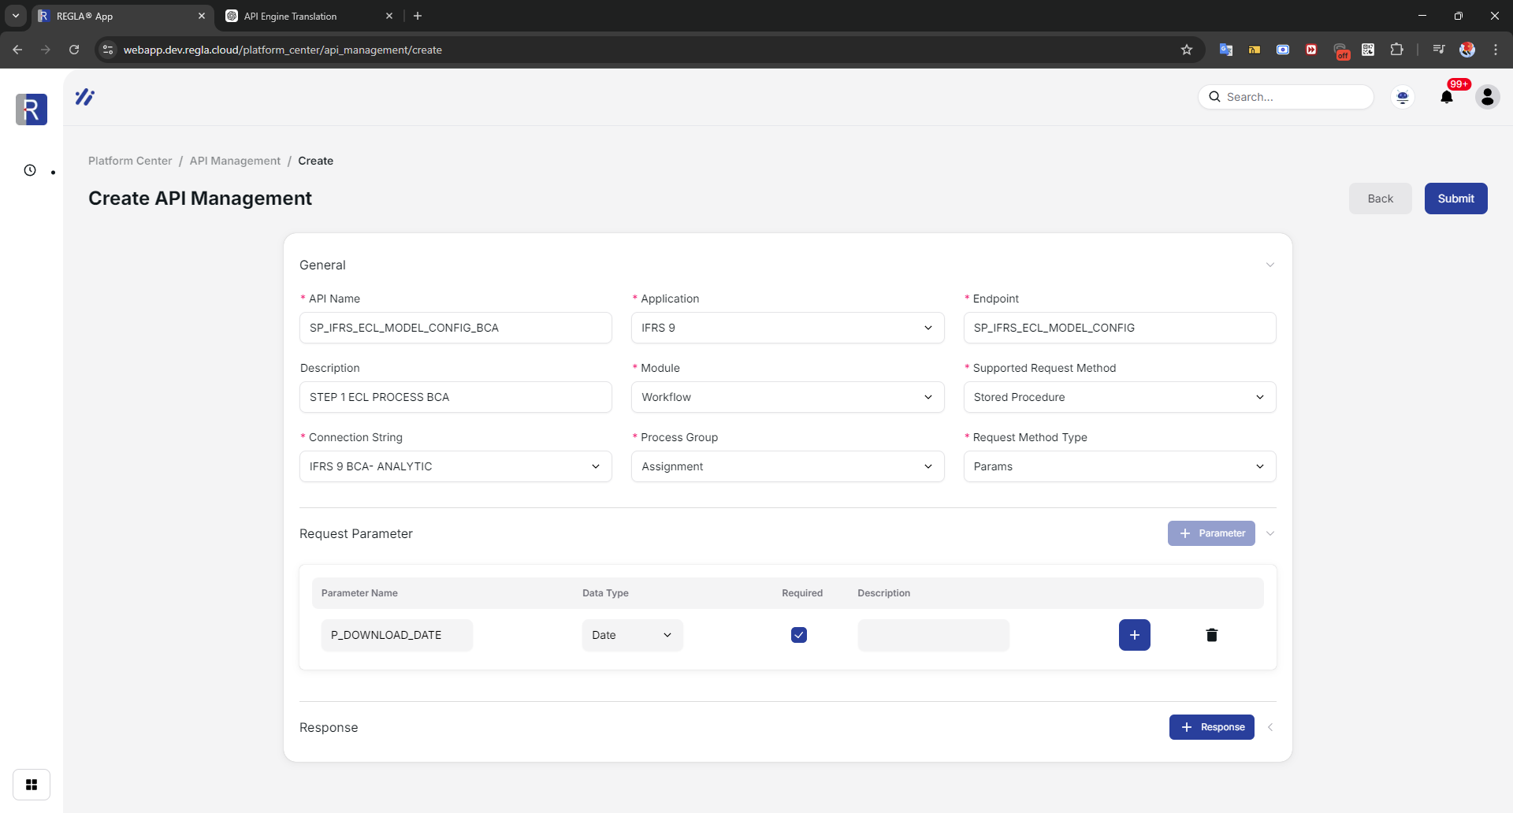
Click Submit to enter the data, and the page will be redirected to the main API Management page.

